**AIM: - Design a system that automatically rings a bell for 2 ms whenever someone enters a temple, assuming only one person can enter at a time.**

**CIRCUIT DIAGRAM: -**

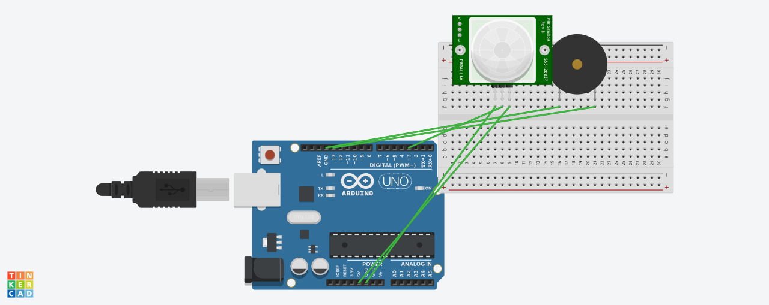

**CONCEPT USED: -**

When a person enters inside the temple, which is detected by sensor then it will give command to the buzzer and it will ring a bell automatically for 2 ms

**LEARNING OUTCOMES: -**

1. Making circuits using Breadboard.2. Using multimeter to apply Resistance on a given LED.3. Working of Arduino UNO.4. Coding to be done on Arduino.exe for stimulation of the experiment.

**PROBLEMS & TROUBLESHOOTING: -**

No problems were occurred during the execution of the experiment.

**PRECAUTIONS: -**

1. The circuit made on breadboard can be wrong.
2. Any Element used can be defective.
3. The coding done for Arduino Board can be incorrect due to which stimulation can be failed.
4. Port Selection for Arduino can be incorrect due to which it won’t upload on Arduino Board and resulting in failure of experiment.

**Learning Outcomes: -**1.Setting up circuit on a Breadboard.2.Using Multimeter.3.Working and coding of Arduino and its IDE.4.Using LDR and learning its features . **Result: -** The system made is able to count the total persons entering in the temple.